
http://iring.ids-adi.org

SDK Guide
Version 1.01.00
Revision History
Document Version # | Action Taken, Notes | Date | Name
1.0 | First release | 01 June, 2009 | Rohit Arora
1.1 | Second release | 16 September 2009 | Rob DeCarlo

Terms of License
Copyright (c) 2009, ids-adi.org
All rights reserved.

Redistribution and use in source and binary forms, with or without
modification, are permitted provided that the following conditions are met:
* Redistributions of source code must retain the above copyright
notice, this list of conditions and the following disclaimer.
* Redistributions in binary form must reproduce the above copyright
notice, this list of conditions and the following disclaimer in the
documentation and/or other materials provided with the distribution.
* Neither the name of the ids-adi.org nor the
names of its contributors may be used to endorse or promote products
derived from this software without specific prior written permission.

THIS DOCUMENT IS PROVIDED BY ids-adi.org ''AS IS'' AND ANY
EXPRESS OR IMPLIED WARRANTIES, INCLUDING, BUT NOT LIMITED TO, THE IMPLIED
WARRANTIES OF MERCHANTABILITY AND FITNESS FOR A PARTICULAR PURPOSE ARE
DISCLAIMED. IN NO EVENT SHALL ids-adi.org BE LIABLE FOR ANY
DIRECT, INDIRECT, INCIDENTAL, SPECIAL, EXEMPLARY, OR CONSEQUENTIAL DAMAGES
(INCLUDING, BUT NOT LIMITED TO, PROCUREMENT OF SUBSTITUTE GOODS OR SERVICES;
LOSS OF USE, DATA, OR PROFITS; OR BUSINESS INTERRUPTION) HOWEVER CAUSED AND
ON ANY THEORY OF LIABILITY, WHETHER IN CONTRACT, STRICT LIABILITY, OR TORT
(INCLUDING NEGLIGENCE OR OTHERWISE) ARISING IN ANY WAY OUT OF THE USE OF THIS
SOFTWARE, EVEN IF ADVISED OF THE POSSIBILITY OF SUCH DAMAGE.
Table of Contents
SDK Guide 1
1.0 Overview 4
2.0 iRING Adapter 4
2.1 Overview 4
2.2 Adapter Service 5
2.3 DataLayer 6
2.3.1 Implementation in iRING Code 7
2.3.2 DataLayer Components 9
2.3.3 DataLayer Interface 10
2.4 DTO Layer 12
2.4.1 Implementation in iRING Code 12
2.4.2 DTO Layer Components 13
2.4.3 CommonDTOInterface 14
2.5 Adapter Service Layer 15
2.5.1 Implementation in iRING Code 16
2.5.2 Adapter Service Layer Components 17
2.5.3 Adapter Interface 18
2.6 Interface Service 21
2.6.1 Implementation in iRING Code 21
2.6.2 21
2.6.3 Interface Service Components 22
2.6.4 Interface Service Interface Definition 23
2.7 Reference Data Service 23
2.7.1 Implementation in iRING Code 24
2.7.2 Reference Data Service Interface 25
3.0 RDS/WIP Editor 28
3.1 RDS/WIP Editor Architecture 28
3.1.1 RDSWIPEditor Silver Light Implementation in iRING Code 30
3.1.2 RDSWIPService Implementation in iRING Code 31
3.1.3 RDSWIPService Interface 31
3.2 Current Scope of RDS/WIP Editor 34
4.0 Mapping Editor 35
4.1 Mapping Editor Architecture 35
4.2 Implementation in iRING Code 35
5.0 Implementers Guide 36
5.1 Development Environment 36
5.1.1 Install Microsoft Visual Studio 2008 with Service Pack 1 36
5.1.2 Silverlight 3 36
5.1.2.1 Install Microsoft Silverlight 3 SDK 36
5.1.2.2 Install Silverlight 3 Tools for Visual Studio 2008 SP1 36
5.1.2.3 Install Microsoft Silverlight 3 Toolkit 36
5.2 Source Code 37
5.2.1 Install Tortoise SVN 37
5.2.2 Checkout Code 37
5.3 Build, Run and Upload 37
An Example Transformation 38

Overview
The iRING is deployed in two packages, iRING Adapter and iRING Sandbox. These packages are separated for the deployment purposes. This will allow implementers to only download the necessary components. The iRING Adapter is used to map and transform legacy data to ISO 15926. The iRING Sandbox is used to host Reference Data of local interest or draft quality for use with the iRING Adapter. iRING Sandbox data should be used locally only or eventually, be submitted to the IDS-ADI Core Team for addition into the RDSWIP. The iRING Adapter will use reference data from configured Sandboxes, as well as the RDSWIP.

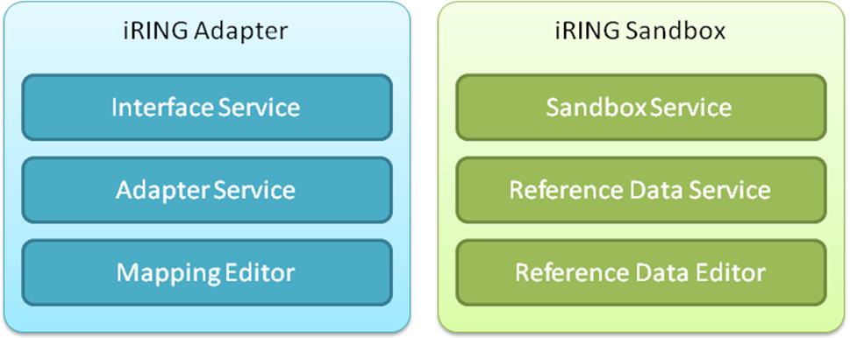

Figure 1: iRING Packages

iRING Adapter

Overview

The iRING Adapter Service is made up of several abstraction modules that represent the legacy data into an ISO 15926, Part 7 form and the iRING Interface Service is a proto “Façade” as defined by ISO 15926, Part 9.

Adapter Service
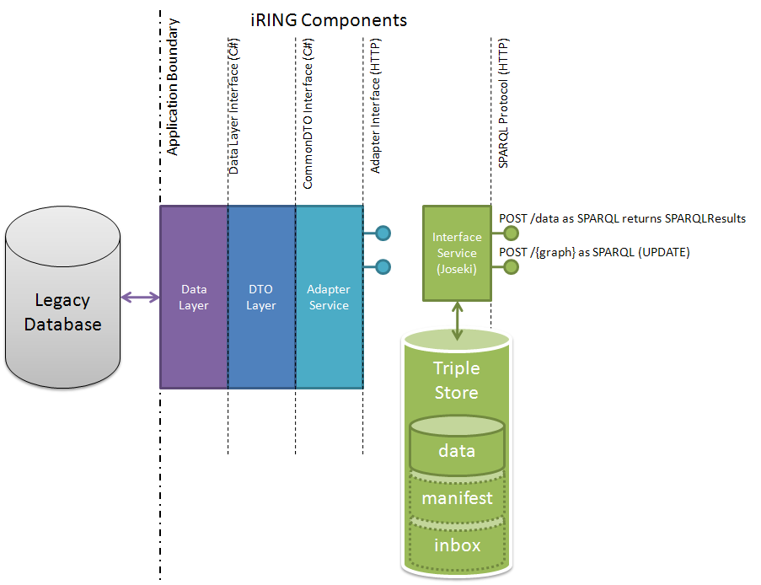

Figure 2: iRING Architecture

The iRING Adapter Service is divided into abstracted layers to allow the reuse of components by future adapter developers. There are three layers:

- iRING DataLayer – Responsible for abstracting the Legacy Database as C# Data Contracts.
- iRING DTO Layer – A DTO is a simple container for a set of aggregated data that needs to be transferred across a process or network boundary. DTO Layer creates Data transfer objects that are used to pass data to Adapter service, to prevent your data layer objects from being exposed to a third party.

- iRING Adapter Service – Responsible for exposing DTO Objects as ISO 15926, Part 7 Model instances (QXF) and also for providing adapter functionality using the above.

The iRING Protocol Specification will govern the interactions between the different layers. Each layer will implement a specified interface.

DataLayer

iRING Datalayer is responsible for abstracting the Legacy Database as C# Data Contracts.

iRING DataLayer has been implemented using ADO.NET Entity Framework concept. ADO.NET Entity Framework is an object-relational mapping (ORM) framework for the .NET Framework. It is designed to enable developers to create data access applications by programming against a conceptual application model instead of programming directly against a relational storage schema. The goal is to decrease the amount of code and maintenance required for data-oriented applications.

The Entity Framework supports an Entity Data Model (EDM) for defining data at both the storage and conceptual level and a mapping between the two. The EDM is defined by the following three model and mapping files that have corresponding file name extensions:

- Conceptual schema definition language file (.csdl) - defines the conceptual model.
- Store schema definition language file (.ssdl) - defines the storage model, which is also called the logical model.
- Mapping specification language file (.msl) - defines the mapping between the storage and conceptual models.

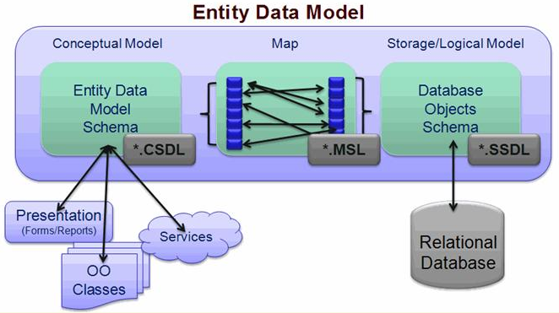

Figure: 3 Entity Data Model
The Entity Framework uses this XML-based model and mapping files to transform create, read, update, and delete operations against entities and relationships in the conceptual model to equivalent operations in the data source.

Entity Framework applications can run on any computer on which the .NET Framework 3.5 Service Pack 1 (SP1) is installed.
Object Services

Automatic generation of entity framework (Using wizard or edmgen utility) also creates a top level layer of the data model (so called Object Services*) implemented as a class which inherits System.Data.Objects.ObjectContext. This class controls the connection to the database and also provides high level operations for interaction with datasource and entities. This class also includes properties and methods named after your database objects. You will use these members to retrieve and modify data in the context. The wizard (or edmgen.exe utility) also creates classes for all selected tables that represent entities. For every data entity that is added in the data model the entity container contains corresponding generics collections that are used to retrieve data from data source.
(*In iRING, the code for Object Services is contained in an auto generated file Model.cs)

For more information on Object Services Layer, Please refer: http://msdn.microsoft.com/en-us/library/bb386871.aspx

Implementation in iRING Code

The datalayer is implemented in iRING solution in following code files:

- <Camelot>\Code\Adapter\AdapterService\App_Data\Model.csdl
- <Camelot>\Code\Adapter\AdapterService\App_Data\Model.ssdl
- <Camelot>\Code\Adapter\AdapterService\App_Data\Model.msl
These three files represent the entity data model of iRING example legacy database file.

- <Camelot>\Code\Adapter\AdapterService\App_Code\Model.cs
This file implements Object Services layer of Entity Framework (Explained above)

These four files are generated automatically while generating entity framework representation of legacy database using fullgeneration.cmd which in turn calls edmgen.exe utility provided my Microsoft for automating entity framework generation. Please see Figure 3

Also, if the EDM(.csdl, .ssdl, .msl) is already existing and only entity Classes need to be generated, we can call entityClassGeneration.cmd, which generates only the Entity Classes (Model.cs)
- <Camelot>\Code\Adapter\AdapterService\App_Data\fullgeneration.cmd
- <Camelot>\Code\Adapter\AdapterService\App_Data\entityClassGeneration.cmd
Command Line automated Generation of Entity Framework Data Model
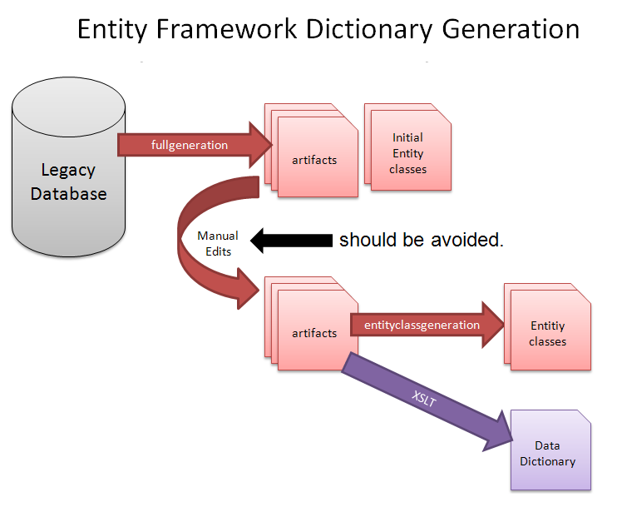

Figure: 4 Entity Framework Dictionary Generation
- <Camelot>\Code\Adapter\AdapterService\App_Code\datalayer.cs
This contains all the datalayer interface methods (e.g. Get, Post etc.) of DataLayer Class.

DataLayer Components

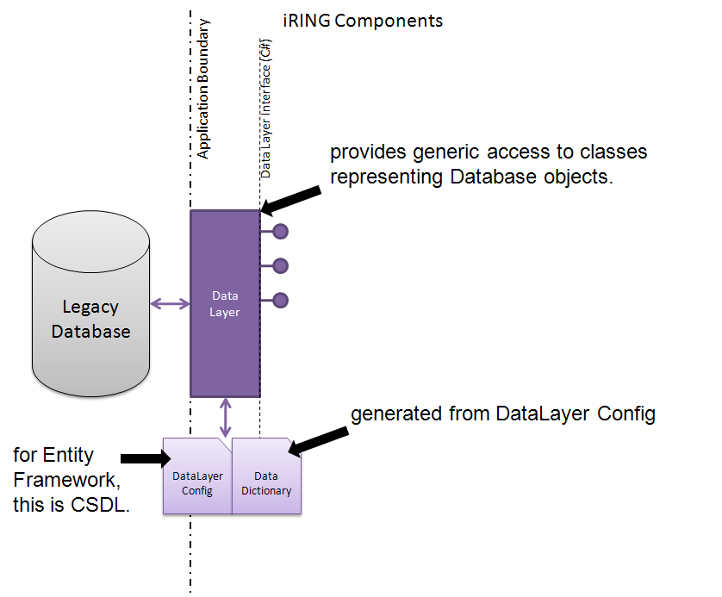
Figure 5: iRING Data Layer Components

Datalayer Components (Refer image above)

- Datalayer Config
In iRING Data layer, Datalayer Config is implemented in .CSDL file. Write some content about the concept and purpose of DataLayer Config.

- Data Dictionary
Data Dictionary (.xml) contains generic XML representation of MetaData as opposed to CSDL which also contains metadata but in proprietary format. DataDictionary.xml is being generated from .CSDL using CSDLtoDataDictionary.xsl

DataLayer Interface

The DataLayer interface implements IDATALayer interface defined in iRING solution in following code file:

<Camelot>\Code\Libraries\iRINGLibrary\IDataLayer.cs

Following methods are available in DataLayer Interface

- Get
- GetList
- Post
- PostList
- GetDictionary
- RefreshDictionary

The method definitions are elaborated below

- T Get<T>(Dictionary<string, object> queryProperties)
Get method gets data from database using entity framework. This method gets data for the requested entity.

  - "T” This is the type of data requested from Get method.
  - "queryProperties" This is collection of the property and its value. This is used to apply the filter.
  - This method returns the single row with data from legacy database, so the data returned is of type T (instance of Valve, line etc.), which is any generic type as per the request.

- This is overloaded method like following

- List<T> GetList<T>(Dictionary<string, object> queryProperties)
GetList method gets data from database using entity framework. This method gets data for the requested entity.

  - "T” This is the type of data requested from Get method.
  - "queryProperties" This is collection of the property and its value. This is used to apply the filter.
  - This method returns the all records from legacy database, so the data returned is a collection of type T, which is any generic type as per the request.

- List<T> GetList<T>()
GetList method gets the complete list of data of a generic type.
- Response Post<T>(T graph)
The Post method posts data into the database using entity framework. This method posts the data in the complete hierarchy of the entity that is passed as a graph. This method also checks that if the record already exists then it updates it else it inserts a new record.

  - "T" This is the type of data that will be posted into the database.
  - "graph" The graph parameter is the container of the data to be posted.
  - The data can be present in hierarchy for the entity.
  - This method returns a response. The response contains the number of records that have been posted successfully/unsuccessfully.

- Response PostList<T>(List<T> graphList)
PostList method posts data into the database using entity framework. This method posts the data in the complete hierarchy of the each entity in a list that is passed as a list of graph. The method also checks that if the record already exists then it updates it else it inserts a new record.

  - "T" This is the type of data that will be posted into the database.
  - "graphList" The graphList parameter is the list container of the data to be posted.
  - The data can be present in hierarchy for the entity.
  - This method returns a response. The response contains the number of records that have been posted successfully/unsuccessfully.

- DataDictionary GetDictionary()

DataDictionary method gets the data dictionary.

- Response RefreshDictionary()
RefreshDictionary method refreshes the data dictionary.

DTO Layer

A DTO is a simple container for a set of aggregated data that needs to be transferred across a process or network boundary. It normally limits its behavior to activities such as internal consistency checking and basic validation. Data transfer objects are used to pass data to consumers of your web/wcf services, to prevent your data layer objects from being exposed to a third party. Though the Entity Framework creates an effective data layer in a .Net application, the generated objects should be used internally to access your data store, and should never be sent out to a third party.

Implementation in iRING Code

The datalayer is implemented in iRING solution in following code files:

- <Camelot>\Code\Adapter\AdapterService\App_Data\CommonDTO.cs

This file implements PropertyDTO Class and CommonDTO Class. Write some Content about CommonDTO Concept and iRING CommonDTO implementation

- <Camelot>\Code\Adapter\AdapterService\App_Data\ModelDTO.cs
This File is generated by invoking MappingToDTOClasses.xsl through Generate() method of Adapter Service. It Contains DTO Classes for each entity in Data Layer (E.g. ValveDTO for Valve Entity etc.).

It also contains DTOFactory Class which has methods for accessing Entity Data from Data Layer and passing it on to Adapter Service Layer as DTO objects.

DTO Layer Components

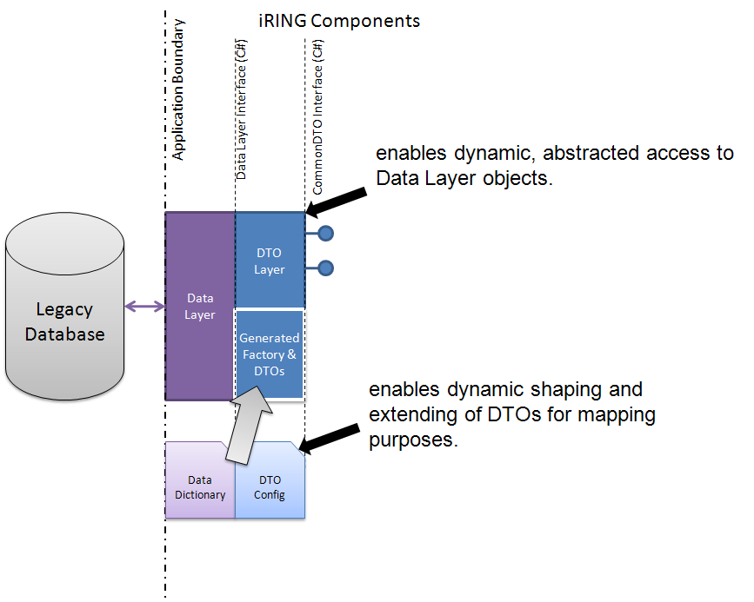

Figure 6: iRING DTO Layer Components --Get updated Image

DTO Config – Not applicable anymore

DTO Factory
The Data transfer object factory does not create any data transfer object as such. The Data transfer object factory in turn uses a command pattern to invoke the specific command that will handle the DTO creation. The DTO Specific command will have all the entity relationship info needed to create the DTO. It will then invoke the Data access objects abstract factory to get the appropriate factory and then it will call that factory to get the DAO from which it gets the entity values. In iRING, the concept of DTO Factory is implemented in DTOFactory Class present in ModelDTO.cs. Invoking the methods of DTOFactory Class (e.g.GetList etc.) leads to creation of <Entity>DTO.xml (e.g LineDTO.xml etc.)
.

CommonDTOInterface

The CommonDTOinterface implements IDataService interface defined in iRING solution in following code file:

- <Camelot>\Code\Adapter\AdapterService\App_Code\IDataService.cs

This File is generated in iRING by invoking MappingToIDataService.xsl through Generate() method of Adapter Service.

Following methods are available in CommonDTO Interface

- GetDTO
- GetDTOList

The method definitions are elaborated below

- CommonDTO GetDTO(string graphName, string identifier)
GetDTO method fills data in object of CommonDTO type using LINQ query .This method gets data for the requested entity.

  - "graphName” This is the name of entity requested.
  - "identifier" This is id of entity requested.
  - This method returns the object of CommonDTO type with data from legacy database

- Dictionary<string, string> GetDTOList(string graphName)
GetDTOList method is returning pair of Identifier & Uri for any entity (like Valve, Line) as a dictionary collection.

  - "graphName” This is the name of entity requested.
  - This method returns the dictionary as a collection.

Adapter Service Layer

The role of the iRING Adapter Service is to:

- Get and update Manifest data to configure the adapter, and post QXF to the iRING Interface Service to enable refresh functionality. (Note: QXF is an XML format of Part 7 data)
- Use Manifest data to generate SPARQL queries to enable pull functionality.

The service will be built in C# using the .NET Framework 3.5 SP1 specifically using the Windows Communication Foundation and Entity Framework. The use of QXF will prevent the need for any .NET semantic web libraries.

Implementation in iRING Code

The Adapter service layer is implemented in iRING solution in following code files:

- <Camelot>\Code\Adapter\AdapterService\App_Code\AdapterService.cs

It provides methods that directly communicate with DTOLayer and transforms the Entity Data in DTO form into QXF and RDF format.

Following xslt’s are also invoked by Adapter Service methods for transformation:

- <Camelot>\Code\Adapter\AdapterService\XML\DTOtoQXF.xsl
- <Camelot>\Code\Adapter\AdapterService\XML\QXFtoRDF.xsl

Adapter Service Layer Components

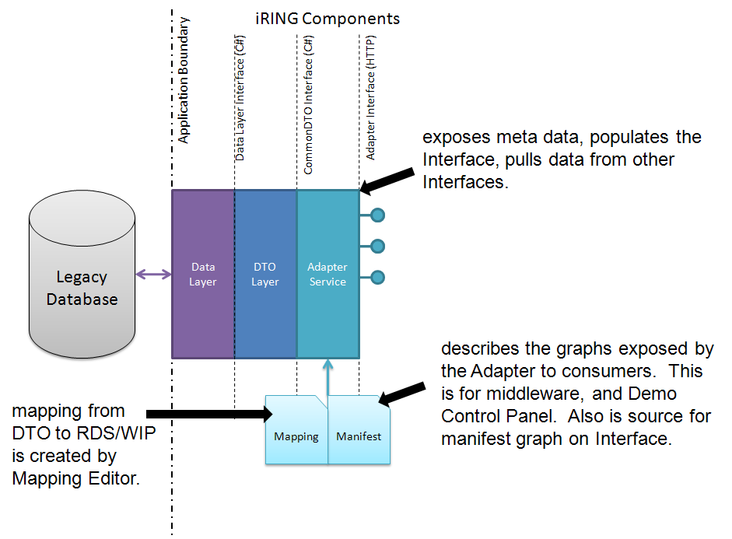
Mapping
This (.xml)file contains mapping of Legacy Data Structure in DTO objects with ISO 15926 Model data present in RDS/WIP. This file is generated from Mapping Editor after the mapping is defined by domain expert.

Adapter Interface

The iRING Adapter Service layer (AdapterService Class) implements IAdapterService interface defined in iRING solution in following code file:

- <iring.svn.codeplex.com>\Adapter\AdapterService\App_Code\IAdapterService.cs

This Adapter Service layer is a WCF web service using the webHttpBinding. The interface is defined by WADL, but will be implemented as a C# interface as well.

Following methods are available in Adapter Interface

- GetDictionary
- RefreshDictionary
- GetMapping
- UpdateMapping
- Generate
- Get
- GetList
- RefreshGraph
- RefreshAll
- Pull
- ClearStore

The method definitions are elaborated below

- DataDictionary GetDictionary()

This method gets the Data Dictionary by reading DataDictionary.xml file located at:

<iring.svn.codeplex.com>\Adapter\AdapterService\XML\ DataDictionary.xml

This method returns DataDictionary.DataDictionary is the information about the data source.

- Response RefreshDictionary()

RefreshDictionary refreshes Data Dictionary by first generating the csdl from the datasource and then updating the DataDictionary.xml from csdl. DataDictionary.xml is located at:

<iring.svn.codeplex.com>\Adapter\AdapterService\XML\ DataDictionary.xml

This method returns returns the response as success/failure.

- Mapping GetMapping()

This method gets the mapping by reading Mapping.xml file located at:

<iring.svn.codeplex.com>\Adapter\AdapterService\XML\ Mapping.xml

This method returns mapping object.
- Response UpdateMapping(Mapping mapping)

This method updates mapping.xml file located at:

<iring.svn.codeplex.com>\Adapter\AdapterService\XML\ Mapping.xml

This method has one input parameter as a mapping object with which the mapping file is to be updated.

This method returns the response as success/failure.
- Response Generate()

This method Generates IAdapterService.DTO.cs , IDataService.cs and ModelDTO.cs. These files are located at:

<iring.svn.codeplex.com>\Adapter\AdapterService\App_Code\IAdapterService.DTO.cs

<iring.svn.codeplex.com>\Adapter\AdapterService\App_Code\IDataService.cs

<iring.svn.codeplex.com>\Adapter\AdapterService\App_Code\ModelDTO.cs

This method returns the response as success/failure.

- Envelope Get(string graphName, string identifier)

Get method gets the data for a graphname and identifier in an Envelope.

graphName is the name of graph for which data is to be fetched.
identifier is the unique identifier used as filter to return single row's data.

Get method returns the specified instance of legacy application data in an Envelope.

- Envelope GetList(string graphName)

GetList method gets all the data for a graphName.

graphName is the name of graph for which data is to be fetched.

GetList returns legacy application data of the specified type in Envelope.

- Response RefreshGraph(string graphName)

RefreshGraph refreshes the triple store for the graphmap passed.

graphName is the name of graph for which triple store will be refreshed.

RefreshGraph updates the Triple Store for the specified type of data and returns the response as success/failure.

- Response RefreshAll()

RefreshAll refreshes the triple store for all the graphmaps and returns the response as success/failure.

- Response Pull(Request request)

Pull method pulls the data from a triple store into the database The Request document is simply a Dictionary<string, string> used to pass named parameters which are specified as follows:

  - targetUri – the uri of the endpoint to query.
  - targetCredentials– the credentials for the target endpoint.
  - graphName– the type of data to query from target.
  - filter – SPARQL FILTER clause to append to the query.

To query the target endpoint, the iRING Adapter Service will need to use the Mapping information to form a SPARQL query to return the expected Results. Using the DTOLayer the legacy database can be updated with the Results.
This method returns the response as success/failure.
- Response ClearStore()
ClearStore method is used to clear the triple store. This method should make the triple store empty by removing data for all graphmaps.
This method returns the response as success/failure.

Interface Service

The role of the iRING Interface Service is to provide SPARQL Protocol access to a Proto Façade Triple Store. This core functionality will be provided by a Joskei server. The server will be configured to use a mySQL database as the data store. Additional functionality may be required to enable SPARQL update and the posting of ISO 15926, Part 8/RDF data.

Implementation in iRING Code

Is it in following files
- <Camelot>\Code\Adapter\AdapterService\App_Code\Sparql.cs

Interface Service Components

Triple Store Joseki implementation
Manifest
Inbox

Interface Service Interface Definition

Reference Data Service

The iRING ReferenceDataService Service will provide picklists and editing functionality to the RDS/WIP Editor. The iRING Mapping Editor will also use the iRING ReferenceDataService for picklists as well.The iRING ReferenceDataService will be a WCF web service using the webHttpBinding.
ReferenceDataService interacts with all available endpoints using SPARQL. All SPARQL query are available in ReferenceDataService

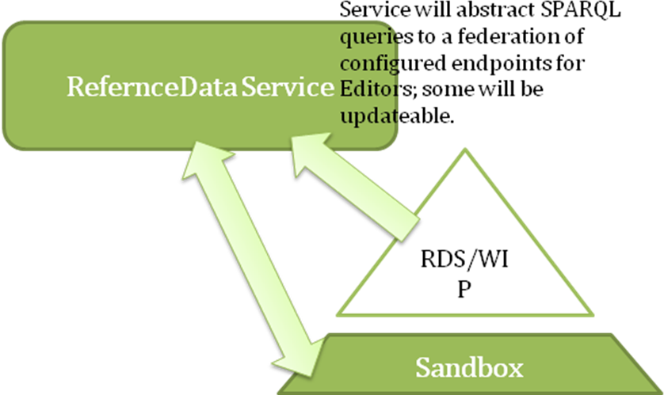

Implementation in iRING Code

The ReferenceDataService layer is implemented in iRING solution in following code files:

- <Camelot>\Code\ReferenceDataService\ReferenceDataService\App_Code\ ReferenceDataService.cs

This service layer has all methods available for interacting with all configured endpoints.

These endpoints are defined as an xml file located at:

- <Camelot>\Code\ReferenceData\ReferenceDataService\XML\Repositories.xml

All the SPARQL Queries referred in Reference Data Service Methods are present in text files located at:

- <Camelot>\Code\ReferenceData\ReferenceDataService\SPARQL

Configuration file is located in iRING in following code files:

- <Camelot>\Code\ReferenceDataService\ReferenceDataService\Web.config

Reference Data Service Interface

The ReferenceDataService interface is implemented in iRING solution in following code files:

<Camelot>\Code\Libraries\iRINGLibrary\ IReferenceDataService.cs

Following methods are available in Reference Data Service Interface

- GetRepositories
- Search
- SearchReset
- SearchPage
- SearchPageReset
- Find
- GetClass
- GetSubClasses
- GetClassRelationships
- GetClassProperties
- GetTemplate
- PostTemplate
- PostClass

The method definitions are elaborated below

- List<Repository> GetRepositories()

GetRepositories method returns all endpoints configured as data source

  - This method returns result as an instance of List<Repository> type

- RefDataEntities Search(string query)

Search method returns all data from all endpoints. All search results contain search parameter. If the search for this parameter has already been executed then next search for the same parameter is returned from cache.

  - "query” This is the search parameter.
  - This method returns search result as an instance of RefDataEntities type

- RefDataEntities SearchReset(string query)

SearchReset method returns all data from all endpoints. All search results contain search parameter. It is always a fresh search

  - "query” This is the search parameter
  - This method returns search result as an instance of RefDataEntities type

- RefDataEntities SearchPage(string query, string page)

SearchPage method returns all data from all endpoints. All search results contain search parameter. If the search for this parameter has already been executed then next search for the same parameter is returned from cache.

  - "query” This is the search parameter
  - “page” This is requested page number
  - This method returns search result as an instance of RefDataEntities type

- RefDataEntities SearchPageReset(string query, string page)

SearchPageReset method returns all data from all endpoints. All search results contain search parameter. If the search for this parameter has already been executed then next search for the same parameter is returned from cache.

  - "query” This is the search parameter
  - “page” This is requested page number
  - This method returns search result as an instance of RefDataEntities type

- List<Entity> Find(string query)

Find method returns only one result with the same name as search parameter from all endpoints.

  - "query” This is the search parameter
  - This method returns search result as an instance of RefDataEntities type

- QMXF GetClass(string id)

GetClass method returns all properties for requested ID of class.

  - "id” This is the identifier of Class.
  - This method returns result as an instance of QMXF type.

- List<Entity> GetSubClasses(string id)

GetSubClasses method returns all properties for requested ID of class.

  - "id” This is the identifier of Class.
  - This method returns result as an object of QMXF type.

- List<Entity> GetClassRelationships(string id)

GetClassRelationships method returns all template related to a class.

  - "id” This is the identifier of Class.
  - This method returns result as an object of List<Entity> type

- List<Entity> GetClassProperties(string id)

GetClassProperties method returns all properties for a class.

  - "id” This is the identifier of Class.
  - This method returns result as an object of List<Entity> type

- QMXF GetTemplate(string id)

GetTemplate method returns all properties & role for a template.

  - "id” This is the identifier of Template.
  - This method returns result as an object of QMXF type

- Response PostTemplate(QMXF template)

PostTemplate method adds a new template to an endpoint.

  - “template” This is an instance of QMXF type which contains template data.
  - This method returns result as an object of Response type

- Response PostClass(QMXF @class)

PostClass method adds a new class to an endpoint.

  - "@class” This is an instance of . QMXF type which contains class data.
  - This method returns result as an object of Response type

RDS/WIP Editor
iRING RDS/WIP Editor is a software application that enables the users to browse the ISO 15926 Part4 and ISO 15926 Part 7 Data existing in RDS/WIP as well as Sandbox(es)(Federation of Configured EndPoints). It also allows users to add new Classes and templates to the Sandboxes.

RDS/WIP Editor Architecture

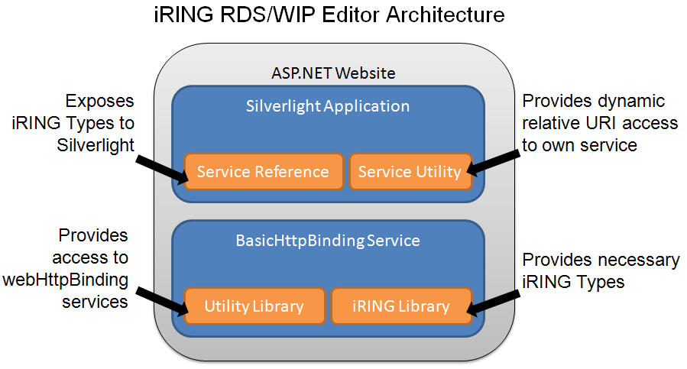

RDSWIPEditor is a silver light application hosted in ASP.Net web site. All the controls developed in silver light application are rendered in ASP .Net web site. RDSWIPEditor application has service utility that provides dynamic relative URI access to own service. This service utility is implemented as a WCF proxy service (RDSWIPService), which is a WCF service with basicHttpBinding.
RDSWIPService in turn calls the methods of Reference Data WCF Web service using Utility Library.
RDSWIPEditor application has following two libraries.
- Utility Library: This provides methods like GET, POST etc. This is independent .net application and it calls ReferenceDataService using ASP.Net classes which supports call to webHttpBinding services (ReferenceDataService).
- iRING Library : This provides the iRING types (QMXF, QXF, Mapping etc.) . RDSWIPEditor application & Reference Data Service are communicating with each other through iRING types. This is independent .net application.
References for both above mentioned libraries are included in RDSWIPEditor application as service references.

RDSWIPEditor Silver Light Implementation in iRING Code

The code for RDS/WIP Editor GUI is available at following location:
- <Camelot>\Code\RDSWIPEditor\RDSWIPEditor\RDSBrowser.xaml

- <Camelot>\Code\RDSWIPEditor\RDSWIPEditor\IRingSpinner.xaml

The RDS/WIP Editor code file attached with above mentioned xaml file is implemented at following location:
- <Camelot>\Code\RDSWIPEditor\RDSWIPEditor\RDSBrowser.xaml.cs

- <Camelot>\Code\RDSWIPEditor\RDSWIPEditor\ IRingSpinner.xaml.cs

Above mentioned code files attached with xaml file in turn calls to RDSWIPService.

RDSWIPService Implementation in iRING Code

WCF Proxy service is implemented in iRING solution at:
- <Camelot>\Code\RDSWIPEditor\RDSWIPEditor.Web\App_Code \RDSWIPService.cs

This file implements the IRDSWIPService interface and methods In this file consumes the methods in ReferenceDataService WCF web service. Methods in WCF Proxy service is interacting with ReferenceDataService WCF web service through iRING types (like QMXF, QXF etc.). Methods in WCF Proxy service is returning result to RDSWIPEditor silverlight client application.

RDSWIPService Interface

Following methods are available in RDSWIPService Interface

- Search
- SearchReset
- SearchPage
- SearchPageReset
- Find
- GetClass
- GetClassifications
- GetSpecializations
- GetSubClasses
- GetClassRelationships
- GetTemplate
- GetRole

The method definitions are elaborated below

- RefDataEntities Search(string query)

Search method returns all data from all endpoints. All search results contain search parameter. If the search for this parameter has already been executed then next search for the same parameter is returned from cache.

  - "query” This is the search parameter.
  - This method returns search result as an instance of RefDataEntities type

- RefDataEntities SearchReset(string query)

SearchReset method returns all data from all endpoints. All search results contain search parameter. It is always a fresh search

  - "query” This is the search parameter
  - This method returns search result as an instance of RefDataEntities type

- RefDataEntities SearchPage(string query, string page)

SearchPage method returns all data from all endpoints. All search results contain search parameter. If the search for this parameter has already been executed then next search for the same parameter is returned from cache.

  - "query” This is the search parameter
  - “page” This is requested page number
  - This method returns search result as an instance of RefDataEntities type

- RefDataEntities SearchPageReset(string query, string page)

SearchPageReset method returns all data from all endpoints. All search results contain search parameter. If the search for this parameter has already been executed then next search for the same parameter is returned from cache.

  - "query” This is the search parameter
  - “page” This is requested page number
  - This method returns search result as an instance of RefDataEntities type

- List<Entity> Find(string query)

Find method returns only one result with the same name as search parameter from all endpoints.

  - "query” This is the search parameter
  - This method returns search result as an instance of RefDataEntities type

- Dictionary<string, string> GetClass(string id)

GetClass method returns all properties for requested ID of class.

  - "id” This is the identifier of Class.
  - This method returns result as an instance of Dictionary<string, string> type.

- List<Entity> GetClassifications(string id)

GetClassifications method returns all “is member of” type classes for requested ID of class.

  - "id” This is the identifier of Class.
  - This method returns result as an object of List<Entity> type.

- List<Entity> GetSpecializations(string id)

GetSpecializations method returns all immediate super class for requested ID of class.

  - "id” This is the identifier of Class.
  - This method returns result as an object of List<Entity> type.

- List<Entity> GetSubClasses(string id)

GetSubClasses method returns all sub classes for requested ID of class.

  - "id” This is the identifier of Class.
  - This method returns result as an object of List<Entity> type.

- List<Entity> GetClassRelationships(string id)

GetClassRelationships method returns all template related to a class.

  - "id” This is the identifier of Class.
  - This method returns result as an object of List<Entity> type

- Dictionary<string, string> GetTemplate(string id)

GetTemplate method returns all properties for a template.

  - "id” This is the identifier of Template.
  - This method returns result as an object of Dictionary<string, string> type

- List<RoleDefinition> GetRole(string id)

GetRole method returns all roles associated with template.

  - "id” This is the identifier of Template.
  - This method returns result as an object of List<RoleDefinition> type

Current Scope of RDS/WIP Editor

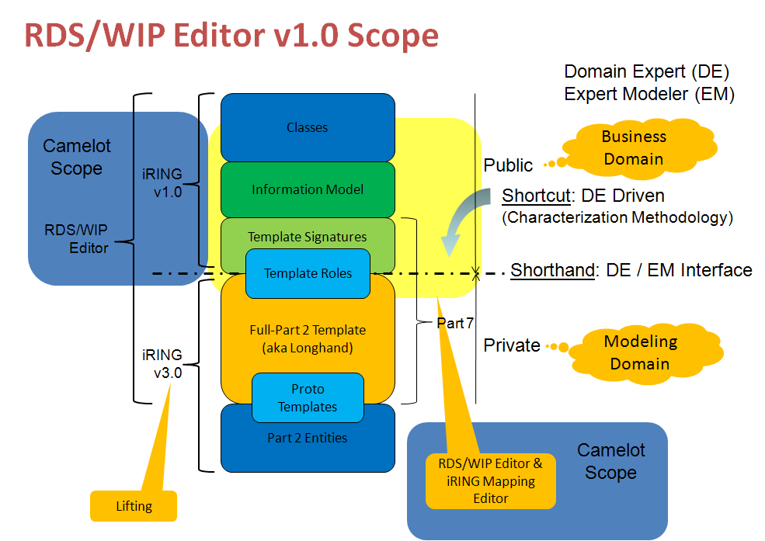

The RDS/WIP Editor, version 1.0 which is the scope of the Camelot project will require the following functionality against the RDS/WIP “Sandbox”:

- Add, Change, and Delete new Part 4 Classes. This will require the specialization from existing RDS/WIP Classes into the Sandbox with new classes.
- Add, Change, and Delete new Part 7 Template Signatures.
- Add, Change, and Delete new Part 7 Template Roles.
- Add, Change, and Delete new Class Relationships (aka OIMs).
- Template Characterization interpreter driven “Wizard”. This should be a generic Wizard engine that would be used for all of the editing objects stated above.

The existing version RDS/WIP Editor has complete Browse functionality and is currently being updated by iRING Development Team to include the complete Add, Change and Delete Functionality.

Mapping Editor

Mapping Editor Architecture

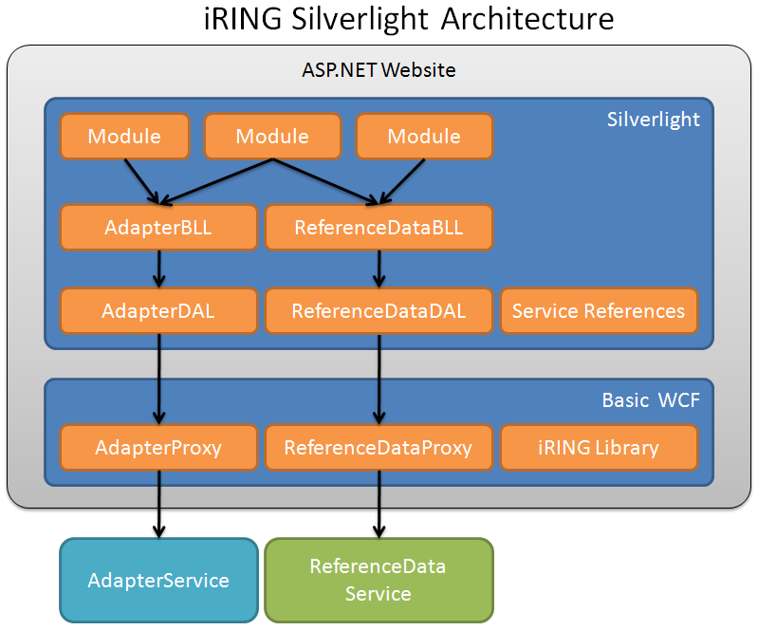

Implementation in iRING Code

Implementers Guide
This section is intended for developers willing to contribute code to the iRing project. Contributing code to iRing is simple and requires a few steps to get started. The following section elaborates on the software requirements required to have an iRing Development Environment (iRDE).

Development Environment
In order to setup your environment to start contributing code to iRing, the following software tools are required as a prerequisite. Please follow the steps below in the order they are mentioned.

Install Microsoft Visual Studio 2008 with Service Pack 1
Some of the iRing components are implemented in C# using the 3.5 .NET Framework. In order for you to use that framework, you will need Microsoft Visual Studio 2008 with service pack 1. Once you have installed Microsoft Visual Studio 2008, you can download service pack 1 from:
http://www.microsoft.com/downloads/details.aspx?FamilyId=FBEE1648-7106-44A7-9649-6D9F6D58056E&displaylang=en

Silverlight 3
Another set of iRing components are implemented using Silverlight. The following steps are required to start developing using iRing and Silverlight.

Install Microsoft Silverlight 3 SDK
The first requirement is to download and install the Microsoft Silverlight 3 SDK. Please make sure you install this package before the remaining packages. You can download the Microsoft Silverlight 3 SDK from:
http://www.microsoft.com/downloads/details.aspx?familyid=1EA49236-0DE7-41B1-81C8-A126FF39975B&displaylang=en

Install Silverlight 3 Tools for Visual Studio 2008 SP1
Silverlight Tools is an add-on for Visual Studio 2008 SP1 for developing Silverlight 3 applications. You can download it from:
http://www.microsoft.com/downloads/details.aspx?familyid=9442B0F2-7465-417A-88F3-5E7B5409E9DD&displaylang=en

Install Microsoft Silverlight 3 Toolkit
The Silverlight Toolkit is a collection of Silverlight controls, components and utilities made available outside the normal Silverlight release cycle. Download is available from:
http://silverlight.codeplex.com/Release/ProjectReleases.aspx?ReleaseId=24246

Source Code
Your environment is ready to contribute code to iRing. This section describes how you can obtain the iRing source code and start contributing. iRing source code is hosted by the codeplex subversion server.

Install Tortoise SVN
There are many Subversion clients available that can be used with CodePlex. TortoiseSVN is a popular Subversion client that works as an extension in Windows Explorer.

Checkout Code
After installing TotoiseSVN, you can obtain the code by following the steps below.
- Go to the Source Control tab of the CodePlex project and make a note of the "Subversion URL" . In this case the url is https://iring.svn.codeplex.com/svn.
- Open Windows Explorer
- Create a new folder where you want to download the source code of the iRing project
- Right click on the new folder and select "SVN Checkout..."
- In the "URL of repository" field enter the Subversion URL https://iring.svn.codeplex.com/svn
- Click OK on the SVN Checkout screen to start downloading the source code files for the project.

Build, Run and Upload
Your iRing folder will now contain a visual studio 2008 solution. Contributing to iRing is as simple as opening the solution with Visual Studio. You can now build the solution and run it. Once you have done your changes, you can upload you code by right clicking on your iRing folder and select “commit”.
Note: Before committing your changes, please contact Rob Decarlo to obtain access to the Codeplex Project as a developer.

An Example Transformation
- Screenshot of Line table in db

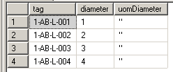

- Screenshot of Line.csdl
<EntityType Name="Line">
<Key>
<PropertyRef Name="tag" />
</Key>
<Property Name="tag" Type="String" Nullable="false" MaxLength="255" Unicode="false" FixedLength="false" />
<Property Name="diameter" Type="Double" />
<Property Name="uomDiameter" Type="String" MaxLength="255" Unicode="false" FixedLength="false" />
</EntityType>
- Screenshot of Line entry in datadictorary.xml
<DataObject>
<dataProperties>
<DataProperty>
<dataType>String</dataType>
<isPropertyKey>true</isPropertyKey>
<isRequired>false</isRequired>
<propertyName>tag</propertyName>
</DataProperty>
<DataProperty>
<dataType>Double</dataType>
<isPropertyKey>false</isPropertyKey>
<isRequired>false</isRequired>
<propertyName>diameter</propertyName>
</DataProperty>
<DataProperty>
<dataType>String</dataType>
<isPropertyKey>false</isPropertyKey>
<isRequired>false</isRequired>
<propertyName>uomDiameter</propertyName>
</DataProperty>
</dataProperties>
<dataRelationships></dataRelationships>
<objectName>Line</objectName>
</DataObject>

- QMXF for Line

<?xml version="1.0" standalone="yes"?>
<!DOCTYPE qmxf SYSTEM "http://ns.ids-adi.org/qxf/model.dtd" [
<!ENTITY xsd "http://www.w3.org/2001/XMLSchema" >
]>
<qmxf xmlns="http://ns.ids-adi.org/qxf/model#">
<class-definition id="http://rdl.rdlfacade.org/data#R45162754880">
<name>IN-LINE PIPING COMPONENT</name>
<entity-type reference="http://dm.rdlfacade.org/data#ClassOfInanimatePhysicalObject" />
<description>A piping component that is installed in a pipeline in such a manner that the centreline between its end connections coincides with the centreline between the adjacent pipeline components</description>
<textual-definition />
<specialization reference="http://rdl.rdlfacade.org/data#R50920869909" />
<status />
</class-definition>

<template-definition id="http://tpl.rdlfacade.org/data#R71909476190">
<name>ClassifiedIdentification</name>
<description />
<textual-definition />

<role-definition id="http://tpl.rdlfacade.org/data#R27212951029" range="http://rdl.rdlfacade.org/data#R95758656562">
<name>object</name>
<description />
</role-definition>

<role-definition id="http://tpl.rdlfacade.org/data#R48396386539" range="http://www.w3.org/2001/XMLSchema#string">
<name>identifier</name>
<description />
</role-definition>

<role-definition id="http://tpl.rdlfacade.org/data#R27019642980" range="http://rdl.rdlfacade.org/data#R43403669880">
<name>context</name>
<description />
</role-definition>

<status />
</template-definition>

<template-definition id="http://tpl.rdlfacade.org/data#R59703910622">
<name>IndirectPropertyScaleValue</name>
<description />
<textual-definition />

<role-definition id="http://tpl.rdlfacade.org/data#R61812604527" range="http://rdl.rdlfacade.org/data#R82407290725">
<name>hasClass</name>
<description />
</role-definition>

<role-definition id="http://tpl.rdlfacade.org/data#R67441507824" range="http://rdl.rdlfacade.org/data#R91740875324">
<name>hasIndirectProperty</name>
<description />
</role-definition>

<role-definition id="http://tpl.rdlfacade.org/data#R29172351027" range="http://rdl.rdlfacade.org/data#R35622698489">
<name>scale</name>
<description />
</role-definition>

<status />
</template-definition>

<template-qualification id="http://tpl.rdlfacade.org/data#R21969261561" qualifies="http://tpl.rdlfacade.org/data#R71909476190">
<name>In-line Piping Component Name</name>
<description />
<textual-definition />

<role-qualification qualifies="http://tpl.rdlfacade.org/data#R27212951029" range="http://rdl.rdlfacade.org/data#R45162754880">
<name>object</name>
</role-qualification>

<role-qualification qualifies="http://tpl.rdlfacade.org/data#R48396386539" range="http://www.w3.org/2001/XMLSchema#string">
<name>identifier</name>
</role-qualification>

<role-qualification qualifies="http://tpl.rdlfacade.org/data#R27019642980">
<value reference="http://rdl.rdlfacade.org/data#R96519909750" />
<name>context</name>
</role-qualification>

<status />
</template-qualification>

<template-qualification id="http://tpl.rdlfacade.org/data#R74614924817" qualifies="http://tpl.rdlfacade.org/data#R59703910622">
<name>In-line Piping Component Nominal Diameter</name>
<description />

<textual-definition />

<role-qualification qualifies="http://tpl.rdlfacade.org/data#R61812604527" range="http://rdl.rdlfacade.org/data#R45162754880">
<name>hasClass</name>
</role-qualification>

<role-qualification qualifies="http://tpl.rdlfacade.org/data#R67441507824">
<value reference="http://rdl.rdlfacade.org/data#R17622148043" />
<name>hasIndirectProperty</name>
</role-qualification>
<role-qualification qualifies="http://tpl.rdlfacade.org/data#R29172351027" range="http://rdl.rdlfacade.org/data#R67037145498">
<name>scale</name>
</role-qualification>

<role-qualification qualifies="http://tpl.rdlfacade.org/data#R88049962134" range="http://www.w3.org/2001/XMLSchema#float">
<name>value</name>
</role-qualification>

<status />
</template-qualification>

</qmxf>

- Entry of Line in Mapping.xml

<GraphMap classId="rdl:R45162754880" name="Line" identifier="tag">

<DataObjectMaps>
<DataObjectMap name="Line" inFilter="" outFilter=""/>
</DataObjectMaps>

<TemplateMaps>

<TemplateMap type="Property" templateId="tpl:R21969261561" name="PipingNetworkSegmentName" classRole="tpl:R71909476190">

<RoleMaps>
<RoleMap roleId="tpl:R48396386539" dataType="xsd:string" propertyName="tag" valueList=""/>
</RoleMaps>

</TemplateMap>

<TemplateMap type="Property" templateId="tpl:R74614924817" name="PipingNetworkSegmentNominalDiameter" classRole="tpl:R59703910622">
<RoleMaps>
<RoleMap roleId="tpl:R29172351027" dataType="rdl:R67037145498" propertyName="uomDiameter" valueList="Length"/>
<RoleMap roleId="tpl:R88049962134" dataType="xsd:float" propertyName="diameter" valueList=""/>
</RoleMaps>
</TemplateMap>

</TemplateMaps>
</GraphMap>

- LineDTO.xml (same records as in legacy)

<Line>
<diameter>1</diameter>
<tag>1-AB-L-001</tag>
<uomDiameter>"</uomDiameter>
</Line>
<Line>
<diameter>2</diameter>
<tag>1-AB-L-002</tag>
<uomDiameter>"</uomDiameter>
</Line>
<Line>
<diameter>3</diameter>
<tag>1-AB-L-003</tag>
<uomDiameter>"</uomDiameter>
</Line>
<Line>
<diameter>4</diameter>
<tag>1-AB-L-004</tag>
<uomDiameter>"</uomDiameter>
</Line>
- Line.QXF.xml for value: 1-AB-L-001 & 1-AB-L-002

<relationship instance-of="http://dm.rdswip.org/data#classification">
<property instance-of="http://dm.rdswip.org/data#class" reference="http://rdl.rdswip.org/data#R58701958436" />
<property instance-of="http://dm.rdswip.org/data#instance" reference="http://www.example.com/data#1-AB-L-001" />
</relationship>
<relationship instance-of="http://tpl.rdswip.org/data#R38263197653">
<property instance-of="http://tpl.rdswip.org/data#R76054703223" as="http://www.w3.org/2001/XMLSchema#string">1-AB-L-001</property>
<property instance-of="http://tpl.rdswip.org/data#R97418641895" reference="http://www.example.com/data#1-AB-L-001" />
</relationship>
<relationship instance-of="http://tpl.rdswip.org/data#R83606034170">
<property instance-of="http://tpl.rdswip.org/data#R87480864844" as="http://rdl.rdswip.org/data#">"</property>
<property instance-of="http://tpl.rdswip.org/data#R91079750503" as="http://www.w3.org/2001/XMLSchema#float">1</property>
<property instance-of="http://tpl.rdswip.org/data#R97418641895" reference="http://www.example.com/data#1-AB-L-001" />
</relationship>
<relationship instance-of="http://dm.rdswip.org/data#classification">
<property instance-of="http://dm.rdswip.org/data#class" reference="http://rdl.rdswip.org/data#R58701958436" />
<property instance-of="http://dm.rdswip.org/data#instance" reference="http://www.example.com/data#1-AB-L-002" />
</relationship>
<relationship instance-of="http://tpl.rdswip.org/data#R38263197653">
<property instance-of="http://tpl.rdswip.org/data#R76054703223" as="http://www.w3.org/2001/XMLSchema#string">1-AB-L-002</property>
<property instance-of="http://tpl.rdswip.org/data#R97418641895" reference="http://www.example.com/data#1-AB-L-002" />
</relationship>
<relationship instance-of="http://tpl.rdswip.org/data#R83606034170">
<property instance-of="http://tpl.rdswip.org/data#R87480864844" as="http://rdl.rdswip.org/data#">"</property>
<property instance-of="http://tpl.rdswip.org/data#R91079750503" as="http://www.w3.org/2001/XMLSchema#float">2</property>
<property instance-of="http://tpl.rdswip.org/data#R97418641895" reference="http://www.example.com/data#1-AB-L-002" />
</relationship>

- Line.rdf

<classification xmlns="http://dm.rdswip.org/data#">
<class rdf:resource="http://rdl.rdswip.org/data#R58701958436" />
<instance rdf:resource="http://www.example.com/data#1-AB-L-001" />
</classification>

<R38263197653 xmlns="http://tpl.rdswip.org/data#">
<R76054703223 rdf:datatype="http://www.w3.org/2001/XMLSchema#string">1-AB-L-001</R76054703223>
<R97418641895 rdf:resource="http://www.example.com/data#1-AB-L-001" />
</R38263197653>

<R83606034170 xmlns="http://tpl.rdswip.org/data#">
<R87480864844 rdf:datatype="http://rdl.rdswip.org/data#">"</R87480864844>
<R91079750503 rdf:datatype="http://www.w3.org/2001/XMLSchema#float">1</R91079750503>
<R97418641895 rdf:resource="http://www.example.com/data#1-AB-L-001" />
</R83606034170>

<classification xmlns="http://dm.rdswip.org/data#">
<class rdf:resource="http://rdl.rdswip.org/data#R58701958436" />
<instance rdf:resource="http://www.example.com/data#1-AB-L-002" />
</classification>

<R38263197653 xmlns="http://tpl.rdswip.org/data#">
<R76054703223 rdf:datatype="http://www.w3.org/2001/XMLSchema#string">1-AB-L-002</R76054703223>
<R97418641895 rdf:resource="http://www.example.com/data#1-AB-L-002" />
</R38263197653>

<R83606034170 xmlns="http://tpl.rdswip.org/data#">
<R87480864844 rdf:datatype="http://rdl.rdswip.org/data#">"</R87480864844>
<R91079750503 rdf:datatype="http://www.w3.org/2001/XMLSchema#float">2</R91079750503>
<R97418641895 rdf:resource="http://www.example.com/data#1-AB-L-002" />
</R83606034170>

